May 11, 2017
President Donald Trump
The White House
1600 Pennsylvania Avenue NW
Washington, DC 20500

Dear Mr. President:

My name is Jonathan Hester and I am a registered American voter. I am also well-informed about global climate change. 2016 was the third consecutive year to set the record for warmest global temperature on record. We are causing this warming by burning fossil fuels, which has raised the atmospheric CO₂ concentration to a level far higher than it has been since at least 600,000 years before the evolution of humans, as shown on the plot of peer-reviewed scientific data below. As you can see by the slope of the blue data, we are doing this terrifyingly quickly.

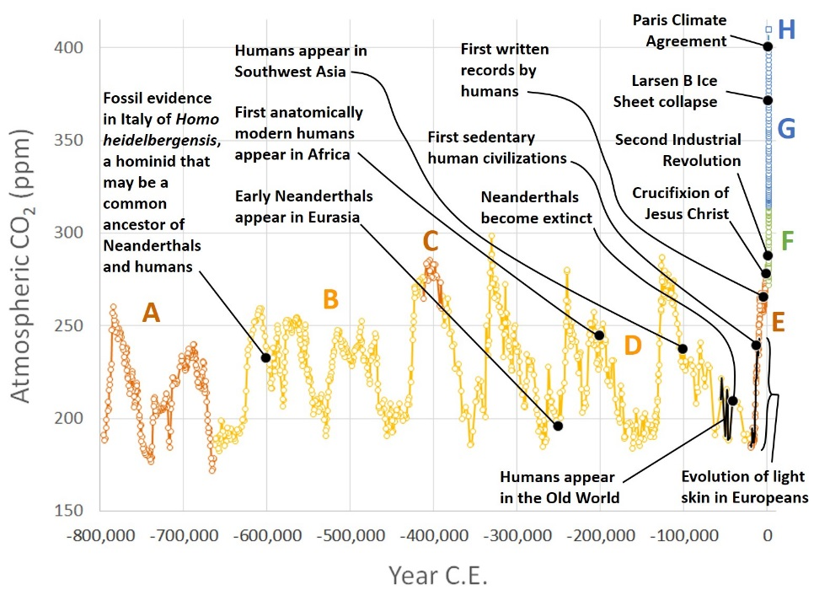
For details and references, see www.rescuethatfrog.com/?p=1085

I have heard your administration is in the midst of a debate about whether to abandon the Paris Climate Agreement, even as solar and wind energy are becoming competitive with fossil energy sources and the U.S. is well-positioned to take a leadership position in a new, sustainable energy economy. To pull out of the Paris Agreement, or to reduce our commitments to that agreement, would be dangerous, short-sighted, irresponsible, cowardly, immoral, shameful, and cruel. It would be a decision to endanger my 3 middle class childrens’ futures in return for some short-term profits for the rich executives of oil and gas companies who lack the imagination to embrace new technology. Please do the right thing, and show America can lead the renewable energy revolution.

Sincerely,

Jonathan Hester, Ph.D.

