March 22, 2017
The Honorable Sean Duffy
2330 RHOB House Office Building
United States House of Representatives
Washington, DC 20515

Dear Representative Duffy:

My name is Jonathan Hester, and I am a scientist living in your district in Hudson, WI. I am writing to you about President Trump’s federal budget proposal of March 16, 2017. I am extremely concerned that it would defund virtually every activity of our federal government related controlling, or even monitoring, Global Climate Change.
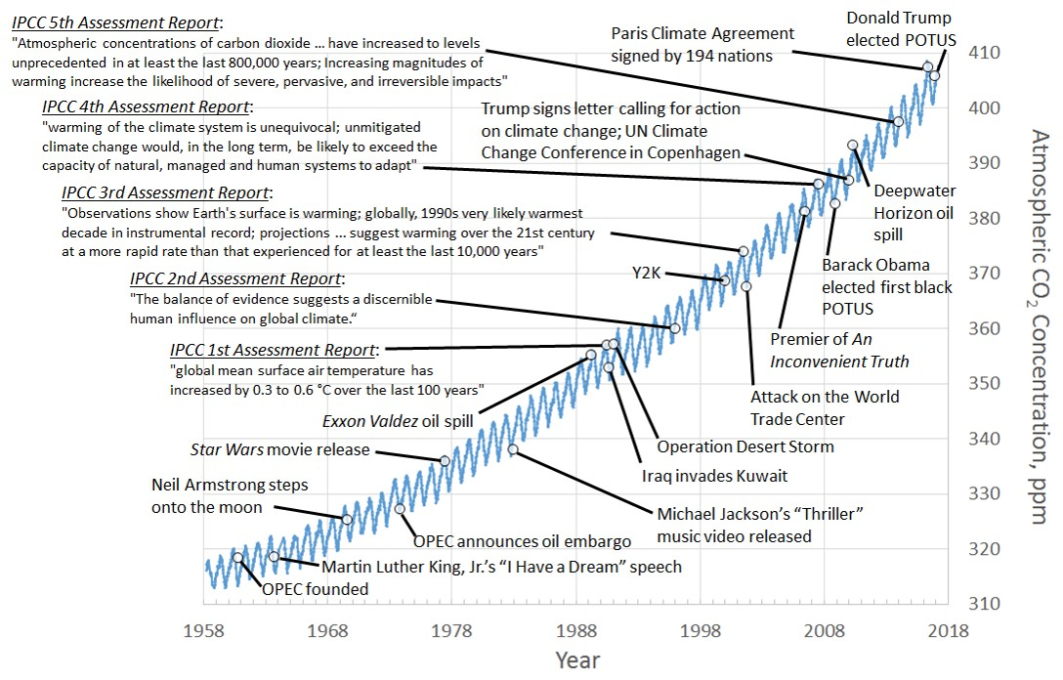
Figure: Blue curve is a plot of atmospheric CO₂ data obtained by the Scripps Institution of Oceanography at Mauna Loa, Hawaii and made available at http://scrippsco2.ucsd.edu/data/atmospheric_co2/primary_mlo_co2_record.

The above curve is a continuous record of the atmospheric CO₂ concentration since 1958 (thanks in large part to funding by the Federal Government). The CO₂ concentration has been increasing at an accelerating rate. Since 1880, the global average temperature has increased by 1.1 °C. This is global warming due to fossil fuel combustion, an undeniable fact for which the scientific literature is now replete with evidence. Anyone who denies this evidence is willfully refusing to confront facts. Extending that willful denial to actual budgetary policy would be irresponsible and disastrous.

Thank goodness Congress, not the President, determines the Federal Budget. In consideration of our children and grandchildren, please make sure we have a budget that ensures we will meet the carbon emission targets we committed to, along with 194 nations, as part of the 2015 Paris Climate Agreement.

Sincerely,

Jonathan Hester, Ph.D.

